**PIZZA SALES QUERY**

1. **KPI**
2. **Total revenue:**

Select SUM(total_price) as total_revenue from pizza_sales;



1. **Avg Order Value:**

Select SUM(total_price)/ COUNT(DISTINCT order_id) as avg_order_value from pizza_sales;



1. **Total Pizzas Sold:**

Select SUM(quantity) as total_pizza_sold from pizza_sales;



1. **Total Orders:**

Select COUNT(DISTINCT order_id) as total_orders from pizza_sales;



1. **Avg Pizzas per order:**

Select CAST (CAST(SUM (quantity) as decimal(10,2))/CAST (COUNT(DISTINCT order_id)as decimal (10,2)) as decimal(10,2)) as Avg_pizza_order from pizza_sales;



1. **CHART REQUIREMENT**
2. **Daily trend total order:**

Select DATENAME(DW,order_date) as order_day, COUNT(DISTINCT order_id) as total_orders from pizza_sales

Group By DATENAME(DW,order_date)

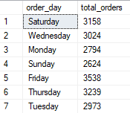

1. **Monthly trend of Total order:**

select DATENAME(MONTH,order_date) as order_month, COUNT(DISTINCT order_id) as total_orders

from pizza_sales

group by DATENAME(MONTH,order_date)

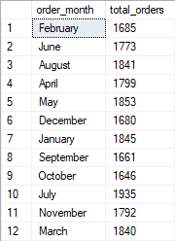

1. **Percentage of Sales:**

Select pizza_category, CAST(sum (total_price)* 100 / (SELECT sum(total_price)from pizza_sales) as decimal (10,2) /*where MONTH(order_date)=5*/) as percentage from pizza_sales

--where MONTH(order_date)=1

group by pizza_category

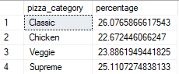

1. **Percentage of sales by pizza size:**

select pizza_size, CAST(sum(total_price) as decimal (10,2)) as total_sales, CAST (sum (total_price)* 100 / (SELECT sum(total_price)from pizza_sales /*where MONTH(order_date)=5*/) as decimal (10,2)) as percentage from pizza_sales

--where MONTH(order_date)=5

--where DATEPART(quarter,order_date)=1

group by pizza_size

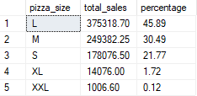order by pizza_size

1. **Total pizzas sold by pizza category:**

select pizza_category, SUM(total_price) as total_sale from pizza_sales

group by pizza_category

order by total_sale

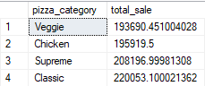

1. **Top 5 Best Seller of pizza:**

select top 5 pizza_name, SUM(total_price) as total_sale from pizza_sales

group by pizza_name

order by total_sale desc

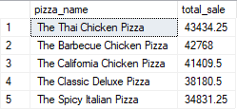

1. **5 worst sellers of pizza:**

select top 5 pizza_name, SUM(total_price) as total_sale from pizza_sales

group by pizza_name

order by total_sale

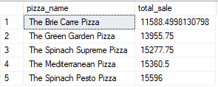

1. **Top 5 Best Seller of pizza by quantity:**

select top 5 pizza_name, SUM(quantity) as total_quantity_sold from pizza_sales

group by pizza_name

order by total_quantity_sold desc

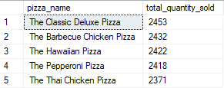

1. **5 worst sellers of pizza by quantity:**

select top 5 pizza_name, SUM(quantity) as total_quantity_sold from pizza_sales

group by pizza_name

order by total_quantity_sold

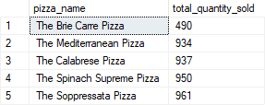

1. **Top 5 Best Seller of pizza by order id:**

select top 5 pizza_name, COUNT(DISTINCT order_id) as total_order_id from pizza_sales

group by pizza_name

order by total_order_id desc

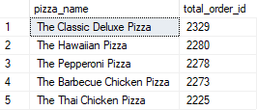

1. **5 worst sellers of pizza by order id:**

select top 5 pizza_name, COUNT(DISTINCT order_id) as total_order_id from pizza_sales

group by pizza_name

order by total_order_id

